IT24104176 PS LAB08

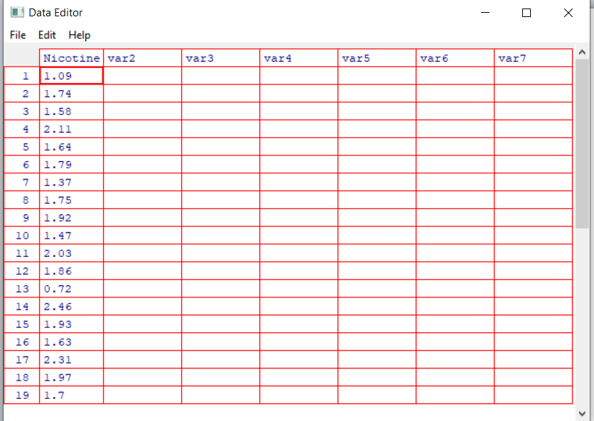

**Q1**



**Q2**

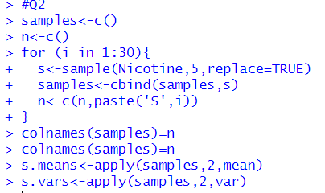

**Q3**

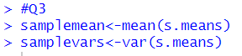

**Q4**

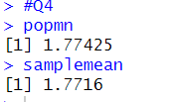

**Q5**

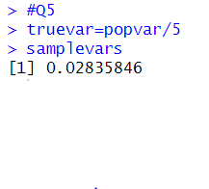

**Exercise**

**Q1**



**Q2**

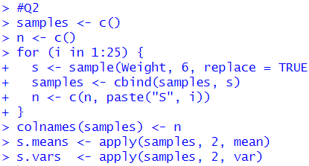

**Q3**



